2023
Year 12 Integrated Science – Unit 4
Task 7: Chemical Reactions Test
Weighting: 5%
Duration: 45 minutes
MARKING KEY

Name: _______________________

Date: _________________
Multi-choice | $${}/{10}$$
Short Answer | $${}/{16}$$
Extended Answer | $${}/{13}$$
Total Mark | $${}/{39}$$

I acknowledge that all the information contained in this task is my own work and not taken from other sources. If other sources have been used, they have been acknowledged in my references.

____________________________________
(Student Signature)

Please see SEQTA for teacher feedback and comments.
MULTI-CHOICE SECTION:
Please answer the below questions by circling the correct answer. (10 marks)

- Which of the following is an example of a physical change?
- A gas being produced when a metal is added to an acid
- Salt crystals dissolving in water
- A solid forming when two solutions are added together
- A temperature increase when a metal is added to water

- During an acid-metal reaction, the products formed from this reaction are:
- Carbon Dioxide and Water
- Metal Salt and Carbon Dioxide
- Metal Salt and Hydrogen Gas
- Carbon Dioxide and Hydrogen Gas

- Which of the following are products of a complete combustion reaction?
- Carbon Dioxide and Carbon Monoxide
- Carbon Dioxide and Water
- Water and Carbon Monoxide
- Oxygen and Carbon Dioxide

- What is the correct formula for Ethane?
- CH₄
- C₁₈H₂₄
- NH₄H
- C₂H₆

- Which is NOT a sign of a chemical change?
- Gas production
- Heat production
- Dissolving
- Colour change

- Steel is used in cars for its corrosion resistance, what is the name of this material?
- Metal
- Composite
- Iron
- Alloy

- Which of the following is not a common property of metals?
- Malleable
- Dull
- Ductile
- Good conductor of heat

- Which of the following is the balanced chemical reaction for the combustion of Methane?
  - CH₄ + O₂ → CO₂ + H₂O
  - 3C₄H_{10.} + 11O_{2.} 12CO₂ + 9H₂O
  - CH₄ + 2O₂ → CO₂ + 2H₂O
  - 3CH₄ + 2O₂ → 3CO₂ + 6H₂O

- Identify which of the below would produce hydrogen gas when reacted with hydrochloric acid (HCl)
  - Aluminium (Al)
  - Calcium carbonate (CaCO₃)
  - Ammonium (NH₄)
  - Oxygen (O₂)

- Hydrocarbons are:
  - Compounds that only contains carbon bonded to itself
  - Compounds that only contain carbon and hydrogen
  - Compounds that do not contain carbon
  - Compounds that contain carbon and other elements

SHORT ANSWER SECTION:

- Identify and explain one example of a physical change. (2 marks)
Substance that: dissolves, forms a mixture, changes shape or changes phase
1 mark: states one of the above 2 marks: explains one of the above

- Provide three indicators for a chemical change (3 marks)
Any three of the following:
- Change in temperature
- Change in colour
- Change in odour
- Production of bubbles
- Production of a precipitate

- 2.5g of a white powder was in a crucible. It was heated with a Bunsen burner until a liquid formed. After cooling a piece of white solid remained. It weighed 2.0g. Explain whether this is a physical or chemical change. Give a reason for your answer. (4 marks)

It is a chemical change (1) because a gas was produced indicated by bubbles (1).
Because the gas was lost to the surroundings the mass after the reaction is less (1).
This is based on the law of conservation of mass - where the mass before and after the experiment should be the same (1).

- For questions a) below, provide the word equation and balanced formula equation, and identify the type of reaction for each.

  - Zinc (Zn) and hydrochloric acid (HCl) react to form zinc chloride (ZnCl₂) and hydrogen gas (H₂) (3 marks)

Word Equation:
Zinc + Hydrochloric acid → Zinc chloride + Hydrogen gas

Formula Equation:
Zn + HCl → ZnCl₂ + H₂

Type of reaction:
Acid / Metal Reaction

For part b) below, supply the missing chemicals, identify the type of reaction and write down the generic equation for each type of reaction. (4 marks)

Magnesium carbonate + sulfuric acid → Magnesium sulfate + Carbon dioxide + water

Type of reaction: Acid / carbonate

Generic reaction equation:
Acid + Metal carbonate → salt + carbon dioxide + water

EXTENDED ANSWER SECTION:
Answer the below questions based on the data provided.

Title: Clean Cities Energy Use Impact by Fuel Type (million GGEs)

Type of fuel | Energy used over time (years)
 | 2004 | 2005 | 2006 | 2007 | 2008 | 2009 | 2010 | 2011 | 2012 | 2013 | 2014 | 2015 | 2016 | 2017 | 2018
CNG | 89 | 56 | 81 | 102 | 104 | 85 | 141 | 167 | 191 | 231 | 293 | 402 | 430 | 426 | 411
Biodiesel | 21 | 47 | 63 | 61 | 74 | 39 | 29 | 70 | 59 | 61 | 59 | 78 | 102 | 94 | 116
E85 | 16 | 26 | 45 | 37 | 37 | 73 | 39 | 49 | 38 | 48 | 51 | 68 | 71 | 86 | 71
LNG | 0 | 8 | 16 | 9 | 14 | 12 | 23 | 28 | 21 | 22 | 34 | 53 | 45 | 47 | 52
Propane | 39 | 32 | 42 | 30 | 25 | 18 | 18 | 19 | 27 | 27 | 32 | 37 | 45 | 44 | 52
Electric | 3 | 2 | 5 | 5 | 4 | 29 | 9 | 16 | 12 | 20 | 27 | 33 | 41 | 26 | 45
Acronyms:
CNG: Compressed natural gas
E85: 85% ethanol, 15% gasoline
LNG: Liquefied natural gas
GGEs= gasoline gallon equivalents

- Provide the missing labels in the table above. (2 marks)

- Identify the following variables from the above table (2 marks)

Independent Variable: type of fuel

Dependent Variable: energy used

- Provide one controlled variable that must have been followed for the data to be collected AND explain why it needs to be controlled. (2 marks)

Any 1 of the following: controlled variable (1) and reason (1)
• The city and country the data is collected. (1) each location around the world would use different amount of each energy depending on number of people, energy sustainability etc.
• The length of each year, same number of days. need to make sure you measure the total amount of energy used over the same period of time, same start and end date.

- Create an appropriate graph to represent the Electric and Biodiesel data from the above table. (5 marks)

- 1 mark – title with independent and dependent variable
- 1 mark – correct axis labels with units
- 1 mark – correct axis scale
- 1 mark – key/legend
- 1 mark – correctly plotted data

- Using the graph above, describe the trends observed and provide an explanation for the results. (2 marks)

From 2004 to 2018 there is a positive trend with both fuels increasing in the amount used
Uses data from the table to support this statement.
Population increases so the amount of fuel used will increase.
The need for cleaner energy use in the environment also increase.

END OF ASSESSMENT

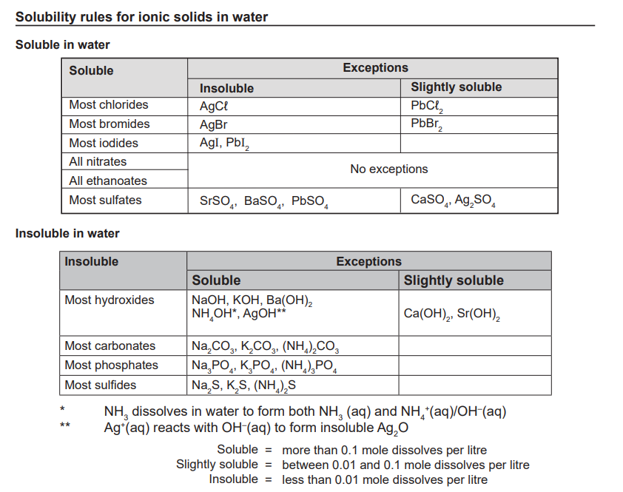

Ion Valency Table
Positive Ions |  | Negative Ions
Name | Symbol | Name | Symbol
Hydrogen | H⁺ | Fluoride | F⁻
Sodium | Na⁺ | Chloride | Cl⁻
Potassium | K⁺ | Bromide | Br⁻
Silver | Ag⁺ | Iodide | I⁻
Lithium | Li⁺ | Hydrogen carbonate | HCO₃⁻
Copper (I) | Cu⁺ | Hydrogen sulfate | HSO₄⁻
Ammonium | NH₄⁺ | Hydroxide | OH⁻
Magnesium | Mg²⁺ | Ethanoate | CH₃COO⁻
Calcium | Ca²⁺ | Nitrate | NO₃⁻
Barium | Ba²⁺ | Oxide | O²⁻
Iron (II) | Fe²⁺ | Sulfide | S²⁻
Cobalt | Co²⁺ | Sulfate | SO₄²⁻
Zinc | Zn²⁺ | Sulfite | SO₃²⁻
Lead (II) | Pb²⁺ | Carbonate | CO₃²⁻
Tin (II) | Sn²⁺ | Nitride | N³⁻
Copper (II) | Cu²⁺ | Phosphide | P³⁻
Aluminum | Al³⁺ | Phosphate | PO₄³⁻
Chromium (III) | Cr³⁺
Iron (III) | Iron³⁺
Tin (IV) | Sn⁴⁺
Lead (IV) | Pb⁴⁺
